The HP 20b Business Consultant as a development platform

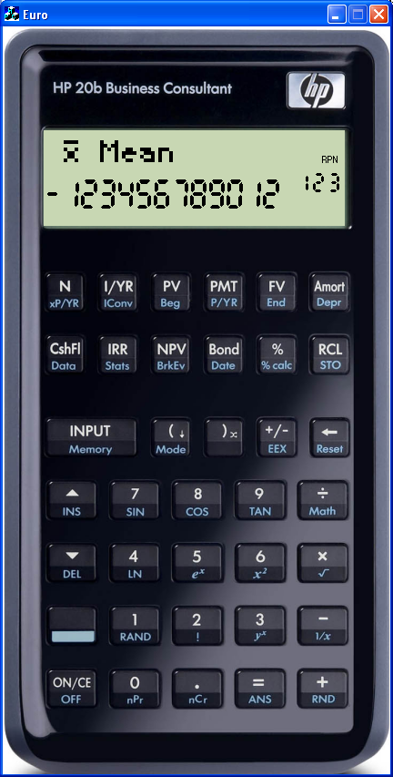

Document prepared by Cyrille de Brébisson (cyrille@hp.com)

Introduction
The HP 20b business Consultant is a great calculator for a business analyst or a realtor, but chances are, if you are reading this document, that you are neither of them, or that you are not reading it as part of your day job but more as a tinkerer or hacker (using the non pejorative meaning of the word).

Well, Welcome to the backside of the HP 20b! and the HP 20b has a lot to offer when you look at it from that angle.

The main feature is that the HP20 b can be reprogrammed with whatever application you have created thanks to the build in 128KB of flash rom in the 30Mhz ARM cpu that powers it. What is means is that if you can think of an application that requires a keyboard, a screen all packaged in a small ‘snazzy’ handheld device, you can create a program that does what you need and put it in the HP 20b, either for your own use, for the use of your company or just for the use of whoever wants or needs it.

If you represent a company that has a need for large volumes, please contact cyrille@hp.com as HP might be able (depending on the cases) to make a special manufacturing run with your program pre-loaded and/or modification to the calculator color and artwork.

HP 20b Hardware
First let us look at the HP20b hardware specifications.

The HP 20b is build around the new Atmel AT91SAM7L128 CPU. The L128 is a low power CPU with an ARM7 running up to 36Mhz, 128KB of flash rom, 6KB of RAM (2KB backup and 4KB volatile) a LCD controller and all the usual peripherals.
The figure bellow (taken from the Atmel documentation available on the www.Atmel.com site at http://www.atmel.com/dyn/products/product_card.asp?part_id=4293 )

Attached to the CPU is a 37 key keyboard and a 400 pixels screen containing a 6*43 matrix display, a 12+3 digits 7 segment display and 11 indicators. The picture bellow shows what the LCD looks like if all the pixels are turned ON.

The calculator schematics are normally provided in this packaged in a separate pdf document called HP20b schematics.pdf.

If you open the calculator (to do that, you will need to remove the battery door, remove the battery and unscrew 5 screws. 3 are clearly visible once you remove the battery door :2 at the top and 1 between the 2 battery, the last 2 screws are hidden under the no slip strip at the bottom of the calculator, to remove the screws, you will need to gently unstuck 6mm of the no slip strip from each side), you will access the PCB which will look like this:
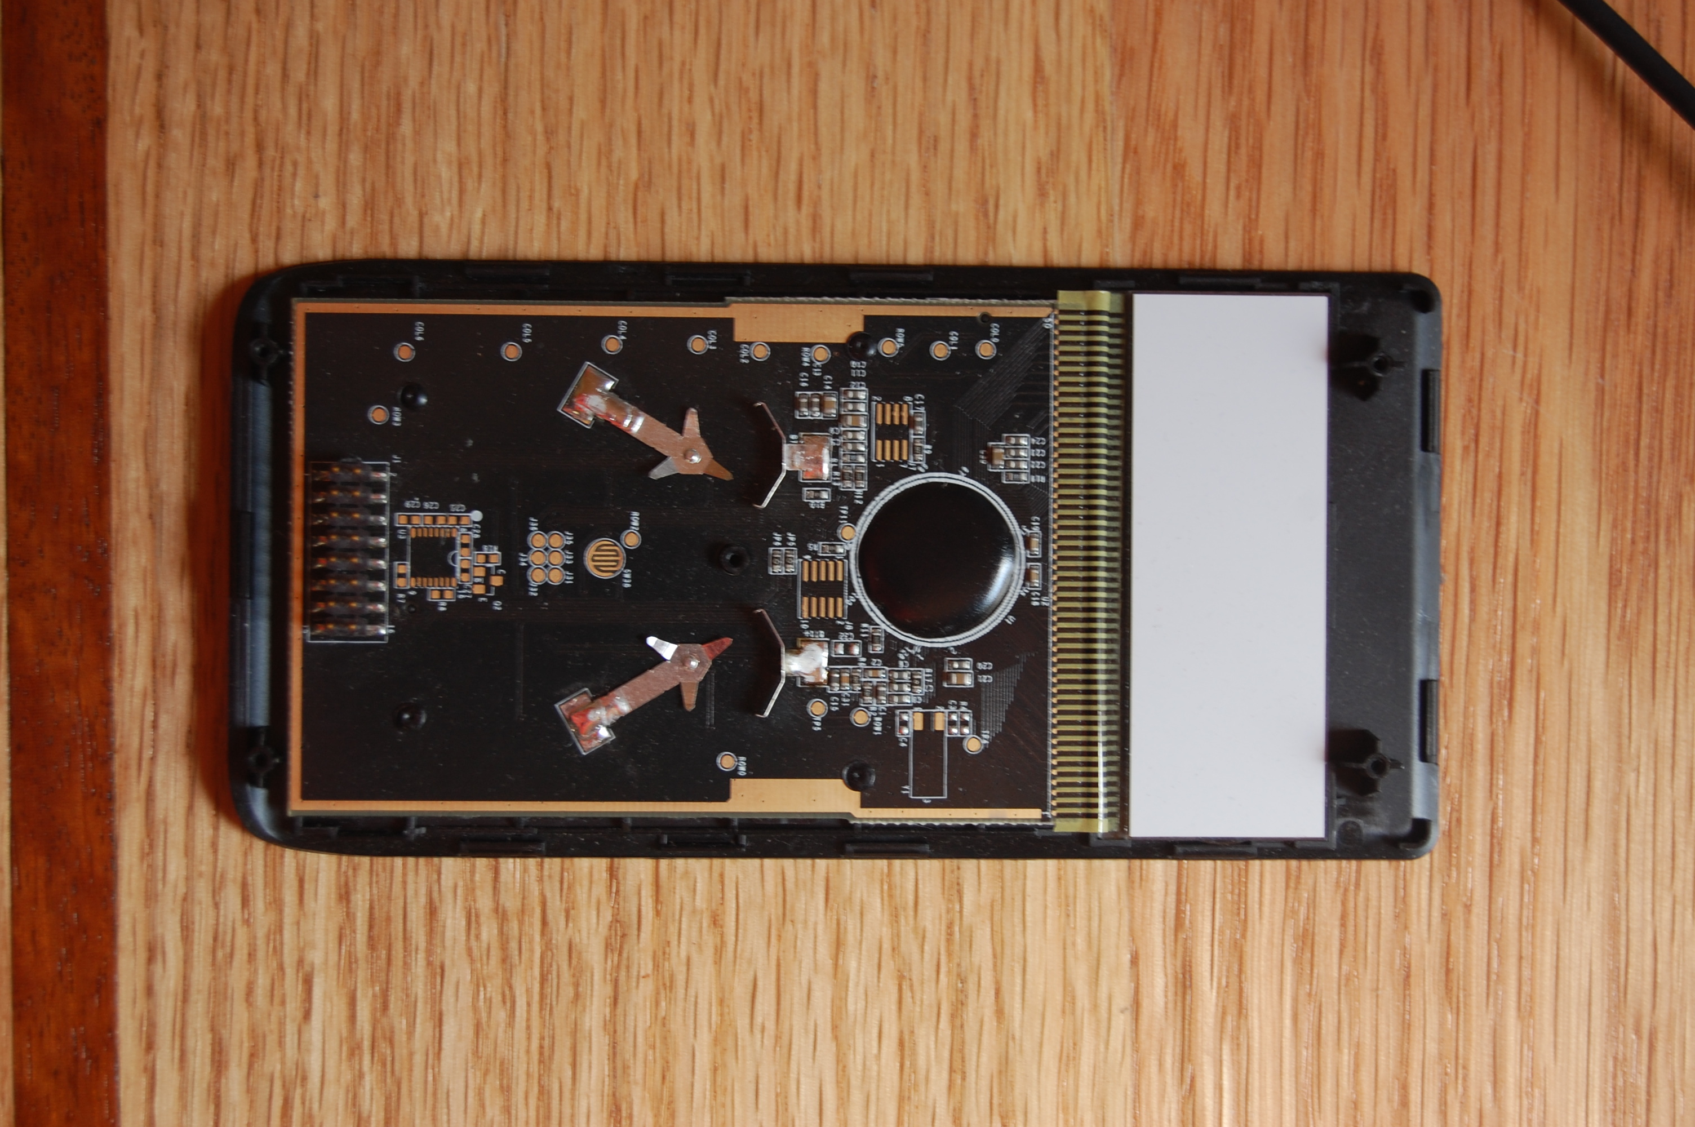
Atmel AT91SAM7L128 cpu
Optional 32Khz cristal
4 ADC channels
Serial connector
JTAG interface
Optional RS232 tranceiver
8 digital IOs

The CPU and the screen are of little interest as they can not easily be modified (the CPU is a wirebonded die under a blob of black “plastic”, and the LCD is connected via a head bonded strip). However, they are a couple of pads on the PCB that do not have any components connected to them. Among the most important:
- The 16 pin Jtag connector
- The Serial connector
- The ‘Free’ IO and ADC pads
- The optional RS232 transceiver
- The optional Cristal pad

Let us look at these 5 items in turn

JTAG connector
JTAG is the name of the interface used for application development (and CPU programming). More will be said about JTAG later on, however, what you need to know is that you probably will want to connect to the JTAG connector. The connector is design to accept a standard 2.54 mm pitch surface mounted header which will connect in turn to the external JTAG interface and the development tools on the PC.
The JTAG connector is conveniently placed under the center of the depressed area (designed to engrave your name of put a nameplate) of the back plastic casing of the calculator, which means that after soldering the JTAG connector, you can, using a box cutter, and exactor knife of a router with a 5/16” or 10mm bit, cutout a hole in the back case and close your calculator for easier development later on. How thoughtful of the engineers ☺

Serial Connector
The serial connector has multiple functions. It’s main raison d’être is to allow reprogramming of the calculator in the field. Using that connector and the proper cable (please contact cyrille@hp.com for more information), you can reset the CPU, erase the flash rom and get access to the Build In boot loader provided by Atmel (SAM-BA).
But, it could also be used by your application for whatever you want. From constant connection to some other device to daily synchronization with a PC, or you could even repurpose the 2 IOs on the connector for something completely different.

The serial connector has 6 pins: Ground, Battery Voltage, Reset (CPU pin), Erase (CPU Pin to erase the flash rom), TX and RX (GPIO pins that can either be used for serial communication or basic IOs).

Free IOs and ADC
These 2 pads give access to 8 digital IOs which can be used either as GPIO, or their multiplexed functions (SPI, PMW or IRQ). They have a 1mm pitch, which is small, but making them larger was causing ESD issues, I hope that this will not be an inconvenience.

Optional RS232 transceiver
The serial connector is connected directly to the CPU, therefore, the serial signal is only 0-3V and does not follow the inverted RS232 convention. However, you can load the optional RS232 pad to have real RS232 signal on the serial port. Please consult the schematics for more information.

Optional 32Khz crystal
The SAM7L128 has a build in 32Khz oscillator, but as always for in silicon oscillators, it is relatively imprecise (+/-10%). This is not a problem for the HP 20b which only uses the oscillator for the approximate 5 minutes auto power off and for driving the PLL (which means that the CPU will run at speed of 30Mhz +/-10%).
However, if you do need precise time measurement (for example if you need to use the Real Time Clock, or need to interact with time sensitive external hardware), you can connect a 32KHz crystal on the board and achieve much higher precision.

Application development
Now that we have looked at the hardware, the next question is: how do you develop for the calculator, and what tools are available.

Compiler
They are lots of ways to do so, from using open source tools (GCC for example), to making your own. At HP, we are using the IAR toolset (compiler, debugger and development environment) version 5.11. You can download a demo version of the tool set from the www.iar.com website (http://www.iar.com/website1/1.0.1.0/675/1/index.php). They are 2 versions available. One with a 30 day limit and the “Kickstart” which does not have the 30 day limit, but is limited to 32KB of generated code. You will have to pick the version which is the most appropriate for you, unless you can afford to purchase a full license.

JTAG
The JTAG In Circuit Emulator allows you to do real time debugging and to easily download your application in the CPU when developing. I strongly suggest that you get one of them. Atmel does have a “cheap” JTAG called the SAM-ICE that you can obtain from Atmel (use the sales contacts button on the bottom left side of their main www.atmel.com homepage) or from other distributors (like digi-key: http://search.digikey.com/scripts/DkSearch/dksus.dll?Detail?name=AT91SAM-ICE-ND) for prices ranging from $120 to $160. If you can not obtain a JTAG, you have 2 solutions: you can develop without, it’s just harder as you can not debug easily, or you can contact me (cyrille@hp.com) as I am trying (no promises there) to setup a loaner program.

Example application
You could start ‘from scratch’, or you could use the code provided by Atmel on their website. But HP is also providing you with a sample application which is probably a much better start than the two other options. In the firmware\AT91SAM7L\compil directory, you will find the file HP20b IAR4.eww that you can open with IAR.

This application is a basic number guessing game where you need to guess a number between 0 and 10000. Enter a number and press INPUT. The calculator will tell you: Too Big, Too Small or WON! and the number of try. The ON key cancels an entry or starts a new game. There is no OFF, but the calculator auto powers OFF after 5 minutes.

Normally, assuming that everything is OK, that you have a calculator plugged in and powered UP (or with the flash ROM erased), you should be able to just start the debugger which should download the application on the calculator and start running it.

Lots of things can go wrong of course. First of all, to be able to download an application, the CPU needs to be turned ON. It can come as a surprise, but most of the time, it is NOT turned on, for example, when the CPU is waiting for a key to be pressed, it is actually turned OFF (even if the screen is ON). It is easy to workaround this problem, keep your finger pressing on one of the key to cause a continuous interrupt which will keep the CPU turned ON allowing a download.
If this does not work try erasing the flash rom by resetting the CPU (reset button) and then connecting the ERASE pin to VBAT (pins 6 and 1 of the serial connector) while pressing the ON key. You will then need to reset the CPU again and restart it by pressing ON again. This should get you out of any “stuck” position.

Once your software is on the calculator, you should be able to debug step by step. However, if at any point the CPU turns OFF, you will loose the connection (thank you IAR). Since the CPU will normally go OFF between key presses, you might want to disable that when debugging by disabling the TurnCalcOff and PutCalcIdle functions.

To make the development easier, HP is also providing a PC emulator of the HP20b. you can open the hp20b_c.sln solution using visual studio 2005, compile it and you will have your same application running on the PC! It makes development and debugging even easier.

Please refer to the in source comments (I know that they are not a lot of them☹) for more information.
The main sources you should look at are: application.cpp and application.h where you should do most of your codding and, to a lesser extent main.c if you need to modify anything system related.

Deployment
When comes time for you to deploy your application to a large number of machines, you can setup the IAR workspace option to ‘binary’ and recompile. This will create a pure binary file that you can download on the calculator using the SAM-BA bootloader (you will need to download SAM-BA from the Atmel website once again). SAM-BA is a built in serial boot loader present in all ATMEL CPU. In order to set the CPU in the SAM-BA mode, you need to erase the flash from. To do that: reset the CPU (reset button), connect the ERASE pin to VBAT (pins 6 and 1 of the serial connector) while pressing the ON key. You will then need to reset the CPU again and restart it by pressing ON again. You should now be in SAM-BA mode and will be able to use SAM-BA to upload the binary file to the calculator (do not forget to finish by executing the script after to tell the CPU to restart from the flash and not SAM-BA at the next boot). You can reset the calculator to run your application.

Conclusion
Well, Have fun! Lots of it, and please do keep me updated on your projects, or contact me if you need help/information. I can not guaranty that I will be able to spend time helping you, but I will do my best.

Cyrille de Brébisson, HP Calculator division, Technical lead

