DXTMON System Overview
Table of Contents
1 Overview 3
2 Interface Description 4
2.1 End User Interfaces 4
2.1.1 Trace Fetcher Interface 4
2.1.2 Wireshark Interface 5
2.2 Administration Interfaces 7
2.2.1 Remote Interface 7
2.2.2 SNMP Interface 9
2.2.3 Configuration Interface 9
2.2.4 SQL Interface 10
2.3 System Interfaces 10
2.3.1 Core Network Interface 11
2.3.2 DXTPCI Feeder Interface 11
References 12

System Description
The DXTMON monitoring system offers a number of interfaces for different purposes. Three different kinds of interfaces are defined:
- End User Interfaces
- Administrative Interfaces
- Interfaces to other systems (e.g. the DataXtender Service & Business Assurance Tool)
Figure 1 shows an overview of the available interfaces.

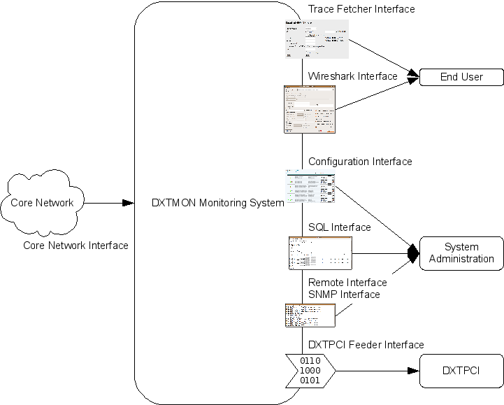
Figure 1: DXTMON Interfaces
To record traffic data from the core network, DXTMON probes have to be placed throughout the network. These must be connected to network taps or splitters in order to obtain traffic from the monitored interfaces. For this task, Endace DAG cards are used. This forms the ‘Core Network Interface’. For a detailed list of supported interfaces, see [Ref]. This functionality is performed by Tracing Nodes documented in [Arch].

For end usesr, a web interface for downloading traces (called ‘Trace Fetcher’) and an online tracing interface (the Wireshark Interface) are provided. This interface is exposed by Trace Fetching Nodes (see [Arch] for details).

For system administration purposes, the SQL Interface, the Remote Interface for querying status information and a web interface for configuration tasks (the Configuration Interface) are available. These interfaces are (mainly) provided by the Management Node and the Trace Fetching Node, respectively (see [Arch]).

For external entities such as the DataXtender Service & Business Assurance Tool, a binary TCP/IP based interface is available. This interface creates so-called ‘tickets’ that are forwarded to the external entity and is provided by DXTPCI Feeding Nodes described in [Arch].

Interface Description
The following chapters describe the available interfaces in more detail.

End User Interfaces
There are two types of end user interfaces available:
- The Trace Fetcher Interface is used to download traffic data and subsequently analyze it offline (e.g. using the open source network analyzer Wireshark);
- The Wireshark Interface is used to open a connection to a tracing probe and displays data in real time; this interface uses a modified version of Wireshark (see 2.1.2 Wireshark Interface).

Trace Fetcher Interface
The Trace Fetcher Interface is shown in Figure 2. It allows end users to download trace files as ERF or PCAP trace files and to view them offline (e.g. using the open source network analyzer Wireshark).
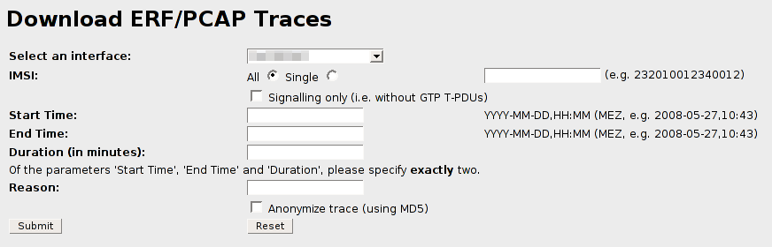
Figure 2: Trace Fetcher Interface
The Trace Fetcher Interface is provided by the Trace Fetching Node (see [Arch]) via a web interface. The open source software Apache is used as web server. Any web browser (Firefox, Opera, Internet Explorer, …) can be used as client software.

The interface allows the user to select the desired interface (in case multiple interfaces are managed by one Trace Fetcher Interface) via a dropdown list and apply a variety of filters. These filters comprise (depending on the actual type of interface, e.g. Gn, Gb,…) the following:
- IMSI
- IP
- Cell
- SAI
- Signaling traffic only
Apart from these (optional) parameters the user has to provide a time frame for which to retrieve traffic (this is mandatory). The user can choose to either provide a start and an end time or to specify a start time and a duration (for which the end time is then automatically computed).

To download a trace file, the user has to provide a reason for his query (this can be a ticket number from an external issue tracking tool, a descriptive string, etc.). This reason is stored together with the current time, the user name (if available), some host information and the actual query information in a local log file and in a central log database.

The user can also choose to anonymize the downloaded trace. In that case, all user-related identifiers (such as the IMSI and the MSISDN) are replaced by an MD5 hash. This guarantees that distinct identifiers are still mapped to distinct hashes, but a correlation to the original values is not possible anymore.

Wireshark Interface
The Wireshark Interface retrieves and displays traces in real time using a modified version of the open source network analyzer Wireshark. It uses the SQL interface presented in 2.2.4 SQL Interface to directly connect to a Trace Fetching Node, which in turn retrieves data from the Tracing Node (see [Arch] for details on this interaction). A description of how to set up a ODBC connection for real time trace retrieval via Wireshark can be found in [Ref].

Figure 3 shows the Wireshark ‘Capture Options’ dialog used to start the capturing process after all necessary preparations have been finished.
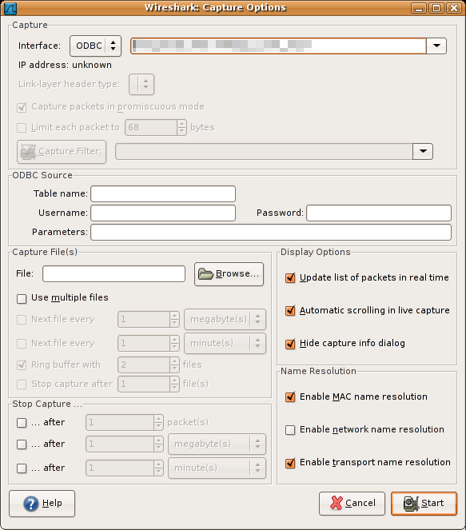
Figure 3: Wireshark Interface
The user can choose the desired ODBC data source from a dropdown list. The name of the data source can be specified in the field ‘table name’. This corresponds to the name of the ‘joined RTABLE instance’ that contains both tracedata and metadata (see [Ref] for details on this). The credentials required to access the data are provided in the form of a user name / password combination. The optional parameter string can be used to pass additional information (filters, reason, anonymization,…) to the server.
After specifying these parameters, the user can press ‘Start’ to start the trace retrieval process.

The table name can be compared to the ‘Interface’ dropdown field in the Trace Fetcher Interface (see 2.1.1 Trace Fetcher Interface). It is used to differentiate between data sources (i.e. interfaces) residing on the same host.

The text field ‘Parameters’ is used to pass an arbitrary SQL string that is appended to the actual query. This can be used to apply filters as well as specifying a reason. Some example parameter strings are given below:

WHERE imsi = 123456789012345 AND time > 2008-05-05,12:00 AND time < 2008-05-05,14:00 LIMIT 5 reason “Test Download”
WHERE signaling = 1 AND time > 2008-05-05,12:00 reason “Real Time download of signaling traffic”
WHERE imsi = 123456789012345 AND time > 2008-05-05,12:00 reason “Real Time download of user traffic”

Traffic data from the past is provided as fast as possible and further arriving traffic is displayed in real time until an end criteria is met. Otherwise new packets are displayed until the user manually aborts the retrieval process. Using the SQL keyword ‘LIMIT’, it is possible to restrict the maximum number of returned packets.

Since Wireshark should only be used to display relatively small sets of data (less than 500MB of data), data retrieved via this interface should always be restricted as much as possible (e.g. the to signaling traffic of a single user). Downloading complete interface traces over even a short period of time will yield to unpractically large trace files.

Administration Interfaces
This chapter presents the interfaces available to a system administrator. These interfaces are:
- The Remote Interface that is used to query status information of various processes (e.g. recording processes);
- The SNMP Interface that offers a standard SNMPv1 interface to the information accessible via the Remote Interface;
- The Configuration Interface, which is a web interface used to manipulate the configurations of various processes;
- The SQL Interface that allows access to trace- and metadata using an SQL client such as ‘psql’;

Remote Interface
Various processes of the DXTMON monitoring system expose runtime information via a proprietary IP-based interface/protocol called ‘Remote Interface’. This interface can be queried using the tool ‘control’, which is provided as part of the monitoring system (see [Ref] for a description of the tool).
The tool allows users to query the status information from any process that is reachable via multicast and supports the Remote Interface.

Figure 4 shows an example query of the information available from a Tracing Node (see [Arch] for an explanation of the term ‘Tracing Node’) using the tool ‘control’.
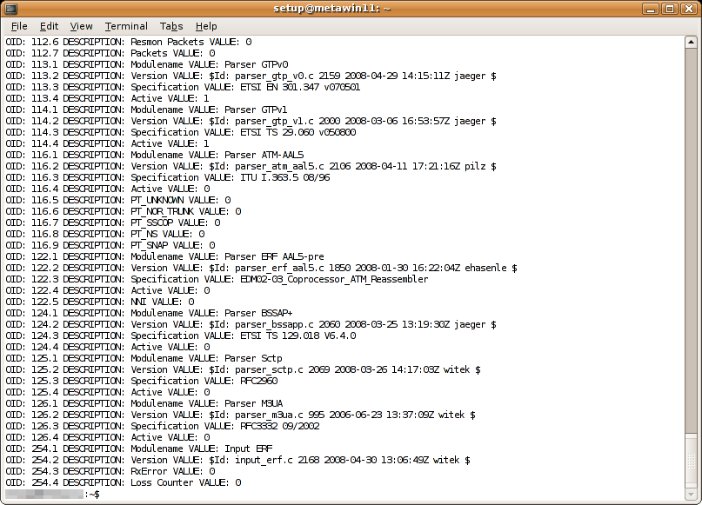
Figure 4: Remote Interface
Each process that can be queried is identified by a unique ID. The variables available within a process are grouped in a tree-like structure of IDs and can be accessed via dot-separated ID strings.
For example, the process ‘motra’ has a remote group with the ID 254 that contains information about the status of the DAG cards it reads from. The IDs ‘254.3’ and ‘254.4’ identify the variable ‘RxError’ and ‘Loss Counter’, respectively (see Figure 4).
For a complete list of available remote groups and IDs, refer to [Ref].

The tool ‘control’ allows the user to
- Iterate (‘walk’) all variables of a process;
- Iterate (‘walk’) all variables of a sub-group of a process;
- Retrieve (‘get’) the value of one specific variable of a process;
- Retrieve (‘next’) the value of the variable following one specific variable of a process;
- Set the value of one specific variable of a process (should be used carefully);

The following components offer status information via the Remote Interface:
- Motra
- SNMP Proxy
- Delay Feeder Server

SNMP Interface
The SNMP Interface offers access to the same information as the Remote Interface, but via SNMP V1. The interface is provided by the Management Node (see [Arch]). Querying is possible using an SNMP V1 client.
In principle, the Management Node converts SNMP V1 messages into Remote Interface messsages and vice versa.
As already indicated in chapter 2.2.1 Remote Interface, each process is uniquely identified by an ID and each variable within the process is identified by a dot-separated ID string. SNMP identifies variables by a so-called OID, which basically is a dot-separated string. In the case of the SNMP Interface offered by DXTMON, this OID is constructed of three parts:

- An arbitrary, configurable prefix (see [Arch] and [Inst]) and common to all processes within DXTMON
- The ID of the process to be queried
- The dot-separated ID string of the variable to be queried

The following example demonstrates this. It assumes the presence of an SNMP Proxy that has the prefix ‘1.2.3’ configured (see [Inst] for a detailed instruction how to configure an SNMP Proxy). The example queries the process identified by the ID ‘4321’ and queries its variable identified by ’17.4’.

snmpget –v1 –c<community string> <Management Node IP> 1.2.3.4321.17.4

The tool ‘snmpget’ is documented as part of the Net-SNMP package available as open source software.

Configuration Interface
The Configuration Interface is a web interface that allows an administrator to create, delete and modify configurations for processes within the DXTMON monitoring system. It is provided by the Management Node (see [Arch]). As server software, the open source web server Apache is used. The configurations are stored in a central database within the node. Figure 5 shows a screenshot of the interface.
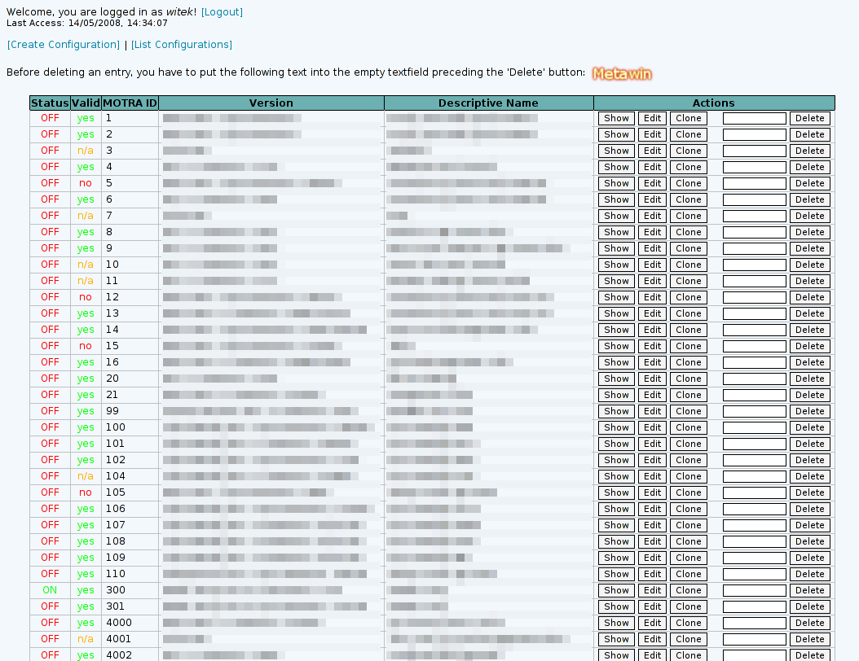
Figure 5: Configuration Interface
All configurations are identified by a unique ID. The same ID is used by the Remote Interface (2.2.1 Remote Interface) and the SNMP Interface (2.2.2 SNMP Interface) to identify the process.
In the top-left corner the user can create new configurations. For each existing configuration, the user can choose to ‘Show’, ‘Edit’ or ‘Clone’ the configuration via the buttons at the right-hand side. The user can furthermore delete a configuration using the button ‘Delete’.

If the SNMP Interface is available, the Configuration Interface uses it to determine and display the status of a process in this table.
If a configuration was invalid (i.e. the process was unable to parse it correctly), this is also visible in the interface.

SQL Interface
The SQL Interface used by the Wireshark Interface (see 2.1.2 Wireshark Interface) can also be queried directly. The interface is provided by a daemon called RTABLE SQL Daemon that exposes data stored within the ringbuffer (see 2.3.1 Core Network Interface for details on how data is stored). This daemon is part of the Trace Fetching Node (see [Arch]).
Figure 6 shows an example screenshot for using the SQL Interface to query data.
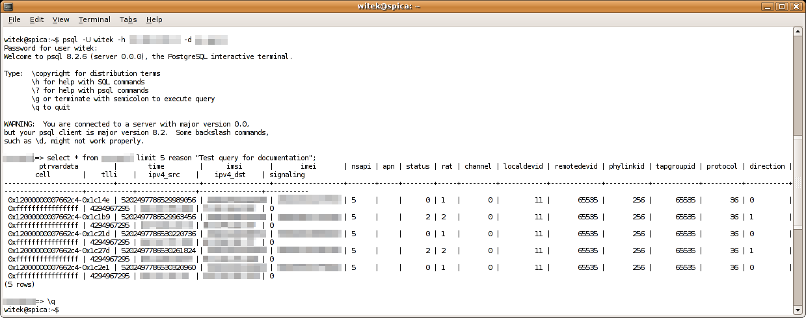
Figure 6: SQL Interface
The SQL Interface uses an implementation of the PostgreSQL protocol, therefore connecting to the interface requires a client that supports this protocol (e.g. ‘psql’, which is available as open source software as part of the PostgreSQL suite). Alternatively, it is possible to use an ODBC connection via a PostgreSQL driver (which basically adds another layer of abstraction).

Since it is mandatory to specify a reason for each data retrieval, each query has to be terminated by the keyword ‘reason’ followed by the actual reason (enclosed in quotation marks, if more than one word, e.g. “reason for downloading the trace”).

A sample query in an SQL client could look like this:

SELECT timestamp, imsi, apn FROM <table name> WHERE time > 2008-05-05,12:00 LIMIT 5 REASON “This is a test query”;

This interface is especially useful for examining the metadata stored within the ringbuffer.

System Interfaces
System Interfaces are those interfaces that interconnect the DXTMON monitoring system with other systems. These are:
- The Core Network Interface, which enables the monitoring system to store network data, since it defines the connection to the actual tracing points (e.g. network splitters); This is the point where the trace data enters the monitoring system.
- The DXTPCI Feeder Interface, which is used to send aggregated traffic information (so-called ‘tickets’) to the DXTPCI system for further processing and analysis;

Core Network Interface
The Core Network Interface defines the entry point for trace data. In practice, this happens in form of network taps or network splitters that are connected to Endace DAG cards that are installed in tracing probes to passively monitor the network traffic. This is done by Tracing Nodes (see [Arch]).
The following interfaces are currently supported:
- Gn
- Gb
- IuPS
- IuCS
- ISP
- Gi
- AAA
- Gr
- Gp

The traffic from these interfaces is processed (including identifier tracking and possibly payload cutting) and stored in a ringbuffer. Data is stored in so-called ‘RTABLE tables’ that contain the binary packet data (and therefore allow packet-level trace retrieval at a later stage) and additional metadata (such as the IMSI, the arrival timestamp, etc.) in a form resembling database tables.
The data is stored in the ringbuffer until it is overwritten by new data (i.e. one iteration of the ringbuffer is complete). The retention time therefore can be calculated from the amount of data written per second and the total storage available.

The data stored in the ringbuffer can be queried using either the Trace Fetcher Interface (see 2.1.1 Trace Fetcher Interface) or the SQL Interface, either by using Wireshark (see 2.1.2 Wireshark Interface) or by using the SQL Interface directly (see 2.2.4 SQL Interface).

DXTPCI Feeder Interface
Using so-called ‘DataXtender Feeders’, it is possible to aggregate the traffic into statistics that are sent periodically to the DXTPCI analysis system in the form of ‘tickets’. This functionality is offered by DXTPCI Feeding Nodes, described in more detail in [Arch].
At the moment, the following feeders are available:
- Active PDP Contexts per IMSI
- Attached subscribers per routing area
- GTPv1 statistics
- IPv4 statistics
- Log message statistics
- Mobile Layer 3 statistics
- PDP Context activation delays
- TCP statistics
- UDP statistics
- HTTP statistics

A further feeder is able to generate delay sample statistics. This feeder does not send its tickets periodically, but event-based. It collects traffic samples from different interfaces and correlates them to generate delay statistics. This is done using a so-called Delay Feeder Server, as documented in [Arch].

More details about the generated tickets can be found in [Intf].

References
[Ref] Kapsch CarrierCom AG, DXTPCI Reference Manual, Issue 3.1.2, May 2008
[Inst] Kapsch CarrierCom AG, DXTPCI Installation Manual, Issue 3.1.2, May 2008
[Intf] Kapsch CarrierCom AG, Interface Specification – MetawinDXT, Issue 3.5, March 2008
[Arch] Kapsch CarrierCom AG, DXTMON – Architecture and Components, Issue 3.1.1, June 2008

