WHITEPAPER THRESHOLD & NOTIFICATION

Report results are not only used for instant problem detection or capacity planning. They deliver important information which can be forwarded to alarming systems to present critical errors in a network. For every result-field in a report, a threshold can be defined to be monitored during report execution. Once a threshold is hit, the associated alarm is generated via SNMP or email.

General remarks on T & N
Thresholds are used to compare report results against certain values that are defined by an operator as critical. Those can be engineering limits or certain thresholds which trigger internal actions. Threshold violation triggers a notification to the DXT user. In its simplest form, the threshold is shown as a red line in the output graph, violating results are coloured red in the table output.

T&N is often used in combination with scheduled reports. This feature allows the user to configure reports with filter parameters and run them in defined timelines. Each report execution triggers the threshold comparison; in case a violation is detected, an SNMP alarm or an email notification is generated.

Release 3.1

Threshold definition based on absolute values

For every result value of a report, threshold values can be set using various comparison operators (=, !=, <, <=, >, >=). Only well-defined explicit numeric (scalar) values can be used to compare the results against. The number of threshold values per result column is configurable site-wide (per DataXtender-Installation) and can be between 1 and 5. The screenshot shows an example of thresholds in DXT Release 3.1 with a single threshold value for each result column.

Typical examples:
- Number of attached subscribers per SGSN > engineering limit
- Call setup success rate < critical value
- Call setup attempts per minute > engineering limit
- Active PDP context per mobile type < proposed marketing value

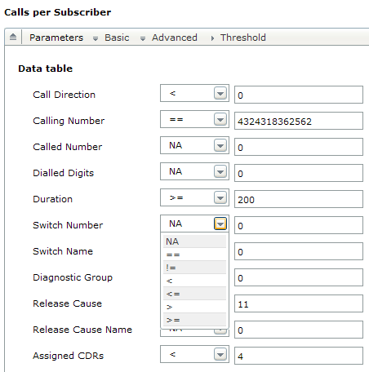

Release 3.2

Relative thresholds – comparison with historic time entities

Compare the values in a time interval or at a point in time with values of previous points or intervals (minute / hour / day / month / …).

The comparison can be performed on two levels:
- Absolute deviation.
E.g. Number of subscribers at hour x is deviating at maximum +/- 20k from hour (x-1).
- Relative deviation.
E.g. Number of subscribers at hour x is deviating at maximum +/- 10% from hour (x-1)

The time range/interval which is used as comparison value is depending on the chosen granularity/interval in the report execution.

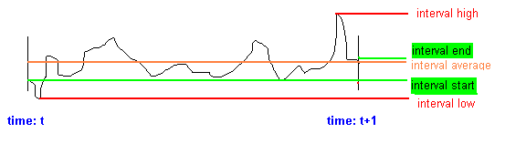

The interval between t and (t+1) contains different values that a report result can have. The base for threshold comparison can be found in different ways:
- Value at the start of the interval (time = t)
- Value at the end of the interval (time = t+1)
- Highest value during the interval
- Lowest value during the interval
- Average value of the interval; this can be found either by applying arithmetic algorithms or by using the median.
Highest/lowest/average value is built upon the chosen granularity. E.g. time interval = 1 hour, granularity = 1 minute >> 60 different values can be used for threshold evaluation.

Relative threshold comparison is always depending on the chosen time interval and can be done against the following time entities:
- Previous minute / hour / day
Example: Compare total call duration for every hour against the one before.
- Comparison against the same time entity (minute/hour/day) from a previous hour/day/month. Example: Compare total call duration for hour x against the same hour the day before.
- Comparison against an aggregated value (trend value) for a historic time period.
Example: Compare total call duration for hour x against the average call duration from the last 24 hours.

The above reference values are pre-calculated by the DataXtender Information Engine at the time the data is loaded into the high performance Star-Data-Structure. Aggregation intervals and their granularity are pre-defined in order to achieve superior response performance. For selected output column (varying with domain package, for example call duration, call success rate, routing call count, link usage, etc.) the maximum, minimum and average over configured intervals (selectable among integer minute, hour, day, optionally week and month) are pre-calculated to be used for threshold comparison.

If the interval of aggregation is small enough, also granularity and intervals different from the pre-calculated ones can be specified and are then calculated “on-the-fly”. The definition of “small enough” as of DataXtender Release 3.2 is defined by a total data set size of 2000 data points.

Typical examples of KPIs and key report results which can be monitored by using scheduled reports and thresholds:
- Subscriber growth
- Link usage
- Call establishment success rate
- Call routing

Relative thresholds – abnormal time events

Thresholds are not valid for each and every time entity that is compared. Peak hours during days are well-known to operators, there is a big climb and drop in user behaviour during those times. But also holidays or weekends show a different call pattern. To avoid alarms when comparing monday’s rush hour with a silent sunday morning, DataXtender T&N allows operator-defined definition of events which can be used to compare only time entities of the same grade.

Peak / Off-Peak
24 hours during each day can be differed into peak and off-peak hours.
This distinction is also possible for weekdays, weekend, holidays.

Calendar entries
Each day can be categorized by the operator by the following distinctions:
- Weekday (Monday – Friday)
- Weekend (Saturday / Sunday)
- Holiday, e.g. Easter Monday, Labour Day
- Bridging days / long weekends
- Special days, e.g. Christmas eve, New Year’s eve

It is also possible to define peak hours during special days where an extreme drop or boost is expected, e.g. new year’s eve from 10 pm to 2 am.

Those definitions are stored as part of the reference data in the DataXtender database.

Choose the comparison
A button allows to
- Compare only with days of the same category
- Compare with all days and hours, neglecting the definitions above

Typical examples:
- Lower data rate during the weekend
- Busy hour shifts from Friday to Saturday
- Higher in-bound roamers during holiday season

Relative thresholds – depending on dynamic values

Thresholds can always be combined with each other when using absolute figures.
Example: Call_setup_success_rate < 93% AND number_of_subs > 100.000

Thresholds for success and failure rates can lead to a lot of alarms during off-peak times if only a small number of users are causing a high number of failures. As the number of concurrent users and the maximum number of users cannot be set in advance, a combination of dynamic and static threshold values is required.
Example: Call_setup_success_rate < 50% AND number_of_subs > 10%_of_max_subs.

Thresholds and Dashboard

Dashboards in DataXtender as of Release 3.2 are user-configurable combined view of a set of report charts.
Therefore, all thresholding functions associated with charts in reports apply also for dashboards.

Thresholds can be combined with the dashboard feature in two ways:
- Dashboard displays the thresholds in a special way (e.g. fixed red line in a bar chart or line chart). Any threshold that is violated when the dashboard is refreshed is shown in the graph.
- Threshold violation is intended to be alarmed with a sound and via SNMP/email. However, as dashboards are not necessarily active or visible, notifications are, for the time being, restricted to scheduled reports.

Document Control

Document History
Date | Issue | Author | Approved | Comment
5.6.2008 | Initial | M.Sedlak | - | Initial
18.6.2008 | 120080618_WS | W.Scherer |  | THNF 3.1 multi level  THNF 3.2 relative historic

