LLM CMS Specification Work Offer
This Document is an offer by:
Wolfgang Scherer
To
CEIT
Concerning the production of a specification for the central management system (CMS) of the system implementing the service functionality in the Long Lasting Memory (LLM) research project.

About this offer
This offer describes work performed in producing the functional and top level implementation specification for the central management system in the Long Lasting Memories research project. Most important, it describes:
- what will be contained in the specification
- in what level of quality and dependability and detail
- how the above information will be obtained and refined
To this effect, this is a meta-specification, specifying a specification and the associated work.

Overall Target
The target of the specification work is a functional and structural specification that may be given to implementing software development teams to be able to nearly immediate commence implementation. “Nearly immediate” means that implementation must not start before 2 activities deemed necessary at the start of the implementation:
Review of the specification by the implementation team
Acceptance and agreement of specification interpretation

Modularity
The specification is intended to be modular in the sense of breaking down the specified systems’ architecture into modules being able to be implemented independently from each other. Furthermore, dependencies of modules amongst each other – however, on a very high level – will be identified in order to allow either an implementation sequence or postponing the implementation of certain modules to a later point of time without compromising the functionality

Template Architecture
In order to estimate the amount of specification work reasonably accurate, the work needs to be broken down into functional entities whose functionality and behavior needs to be specified. However, the architecture of the system is not known at the time of functional specification, much less before specification. In order to break this deadlock situation, this offer assumes an abstract template architecture to identify the class and cardinality of functional entities.
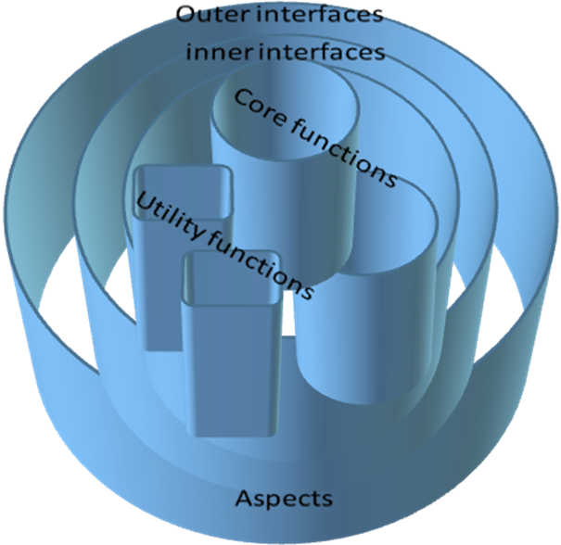

Cardinalities
The following table summarizes the assumptions made about the number of architectural elements to be specified in LLM CMS broken down by type of element
Outer Interfaces | 7
Inner Interfaces | 10
Core functions | 6
Utility functions | 5
Aspects | 20

Work items
Having sketched the template architecture, each architectural entity requires a certain set of work items to reach the required level of specification.
Outer Interface | Outer side  Inner side  performance/volumetrics  technology aspects | 1  1  1  1 | 4 | 56
Inner Interface | Outer side  Inner side  performance/volumetrics  dependencies  technology aspects  modularity aspects | 1  1  1  1  1  1 | 6 | 60
Core function | Function  HMI aspects  configuration  performance/volumetrics  storage/persistence  technology aspects | 1  1  1  1  1  1 | 6 | 36
Utility function | Function  HMI aspects  configuration  performance/volumetrics  storage/persistence  technology aspects | 1  1  1  1  1  1 | 6 | 30
aspect | General requirements | 1 | 1 | 20
Document control and release |  |  |  | 8
Total |  |  |  | 210

