LLMCMSS.06 - LLM CMS Use Cases
This part of LLMCMSS specifies LLMCMS functionalities required by use cases as far they are concerning the LLMCMS.
The use cases are taken from LLMTOS.05 - LLM Operational Specifications.
The use cases described in this part of the specification are the mandatory set of use cases the LLM system shall be able to perform. This part may therefore also serve as the blueprint for the functional part of the system acceptance test.

LLMCMSS.06.00 - Document Control
LLMCMSS.06 document properties
Item | Value
document | LLMCMSS.06
Issue | 0.7
History - 0.1 | Created topics based on LLMTOS
History - 0.2 | added document control
History - 0.3 | Details for use cases, models and scenarios
History - 0.4 | - added screen layout pictures  - adaption to changed login token handling  - add idle screen display  - add use cases for admin and management
History - 0.5 | - formatting corrections  - clarifications concerning separation of responsibilities between LUI and CMS/LRF  - RUI screen layout pictures  - pending: hyperlinks to screen definitions not yet completely inserted (cosmetic)  - add LUI schedule editing screens
History - 0.6 | - add LOGOUT Button to LUI Main Menu Screen #02  - LUI schedule editor is only OPTIONAL, just for study
History - 0.7 | - add LLMCMSS.06.02.01.03 for picture code uniqueness  - remove LUI schedule editor including "+" button in LLMCMSS.06.04.11  - add general design hints in LLMCMSS.06.04 in front  - point out non-goal of automatisms in training program selection in LLMCMSS.06.01.01.3>  - correct editing use case in LLMCMSS.06.05.02  - add navigation use cases to LMCMSS.06.06.06 and LLMCMSS.06.05.02  - change Import to seperate dialogue (LLMCMSS.06.06.06.02) in LLMCMSS.06.06.06  - join LLMCMS.06.01.02 and LLMCMSS.06.01.03

LLMCMSS.06.01 - LLM Service Scenarios - LLMTOS.05.01
The scenarios described in this section are not detailed in their steps and sequence. The functionality required by each requirements item in this section is either covered by other part(s) of the LLM system or further detailed in section LLMCMSS.06.02.

LLMCMSS.06.01.01 - LLMTOS.05.01.01 - LLM for elderly remaining at home
- Home safety monitoring to be performed by ILC
- Integrated (video) telephony to be performed by ILC
- Opposed to LLMTOS.05.01.01.01, training schedules are assumed to be created by a human user in the role therapist.
However, provisions shall be foreseen to enable the following for a post-V1 development (nothing implemented in V 1):
Therapist pre-creates a set of different level training programs.
"applicability" mechanism to use previous results as parameter for the selection of the appropriate training program.
To achieve this, the handling of the "training complete" event shall deposit a "training level" property in the seniors profile in the LLM-DB. The therapist then can e.g. create 2 or more "physical training - treadmill" programs tagged with various "training level" properties themselves. So, when the senior selects the "treadmill" program, only the program with the appropriate currrent training level will be selected.

LLMCMSS.06.01.02 - LLMTOS.05.01.02 - LLM in a day-care center
- ENVREQ: ILC shall have a "speed dial" functionality, accessable by a button from the senior main menu screen, to call the currently assigned personal trainer.
- A danger or distress alert either generated by ILC or by the "alert/help/unwell" button pressed by the senior shall also call the currently assigned personal trainer.
- ENVREQ: PTC shall produce notifications to be displayed by CMS at LUI to drink water etc.
- There shall be arbitrary notifications on the LUI to be confirmed by the logged-in senior. If confirmation is not given after a certain time, an alert situation shall be entered. At alert, any active PTC device shall be frozen/disegaged/powered off. Unfreeze shall be possible by pressing an "OK" button in the displayed notification window.
- Additionally, all requirements of LLMCMSS.06.01.03 apply here also as the clinical institution from the viewpoint of LLM is related to daycare centers

LLMCMSS.06.01.03 - LLMTOS.05.01.03 - LLM in a clinical institution for elderly
- There shall be a simple means to assign a senior to an ILC environment. This can help monitoring a person in a hospital room and generate appropriate alerts. This association shall be stored in the LLM-DB by building a reference form an ILC environment to a senior record.
- Additionally, all requirements of LLMCMSS.06.01.02 apply here also as the clinical institution from the viewpoint of LLM is related to daycare centers

LLMCMSS.06.02 - LLM Use Case Scenarios - LLMTOS.05.02

LLMCMSS.06.02.01 - Login to LLM system
Environment: Local Terminal
Start state: 1.0
State 1.0: Local Terminal logged out, local terminal software running, idle screen #0 displayed
Event 1.0.1: user requests manual login by pressing "manual login" button
Activity 1.0.1: manual login screen #1 displayed, -> state 1.1
Event 1.0.2: user presents login token (by placing smart card on, in or in proximity to reader, depending on technology), token reader software issues "login" event to LLF instance
Activity 1.0.2: login method with token id called in CMS, CMS verifies credentials, creates session and associates with local terminal instance, LLF displays senior main menu screen
LLMCMSS.06.02.01.03 - Picture code uniqueness: Picture code is both secret authentication and identification. Therefore ist must be encrypted (hashed like Unix password) before transmitted onto the network or stored. Additionally, it must be unique across one LLM system instance to uniquely identify exactly one user. This means it must be checked for being unique when created or changed, otherwise rejected.
State 1.1: manual login screen #1 displayed
event 1.1.1: user enters valid picture code, presses "submit"
Action 1.1.1: login method with picture code called in CMS, CMS verifies credentials, creates session and associates with local terminal instance, LLF displays senior main menu screen
event 1.1.2: user enters invalid picture code, presses "submit"
Activity 1.1.2: login method with picture code called in CMS, CMS returns error message, LLF display error message on login screen, -> state 1.1
event 1.1.3: user cancels manual login by pressing "back" button
Activity 1.1.3: idle screen displayed, -> state 1.0
event 1.1.4: user presses "help" button
Activity 1.1.4: display help screen with help for manual login display and procedure

LLMCMSS.06.02.02 - Senior performing traning session
Start State: 2.0
State 2.0: Session logged in, LLM main menu displayed
Event 2.0.1: user presses "cognitive training" and there is only 1 active cognitive training program
Action 2.0.1: LUI queries CMS for CTC programs and start CTC-LUI with the only active training program ID as parameter
Event 2.0.2: user presses "cognitive training" and there is more than 1 active cognitive training program
Action 2.0.2: LUI queries CMS for CTC programs and display cognitive training program selection screen #6, -> to State 2.3
Event 2.0.3: user presses "physical training" and there is only 1 active physical training program
Action 2.0.3: notify PTC and display PTC active screen, -> state 2.4
Event 2.0.4: user presses "physical training" and there is more than 1 active physical training program
Action 2.0.4: display physical training program selection screen #6, -> state 2.3
Event 2.0.5: schedule notification for training
Action 2.0.5: pop up schedule notification screen #05, -> state 2.1
State 2.1: Session logged in, LLM main menu displayed, notification for training program reminder popped up
Event 2.1.1: user presses "start training" button and scheduled training type is physical
Action 2.1.1: notify PTC and display PTC active screen, -> state 2.4
Event 2.1.2: user presses "start training" and scheduled training is cognitive
Action 2.1.2: start CTC wrapper LUI with scheduled training program, -> state 2.5
State 2.2: cognitive training selection screen displayed
Event 2.2.1: user selects one cognitive training
Action 2.2.1: start CTC wrapper LUI with selected training program, -> state 2.5
State 2.3: physical training selection screen displayed
Event 2.3.1: user selects one physical training
Action 2.3.1: notify PTC and display PTC active screen, -> state 2.4
State 2.4: PTC training active, PTC active screen displayed
Event 2.4.1: training completion event from PTC
Action 2.4.1: display training complete and result available hint in PTC active screen, -> State 2.6
State 2.5: CTC training active, CTC controls front window
Event 2.5.1: CTC training complete (event notification from LRF upon termination of feedback calculation)
Action 2.5.1: display training result screen from CTC feedback event, -> State 2.7
Event 2.5.2: user presses "distress" control on CTC user interface
Action 2.5.2: LLF re-acquires screen control, displays distress confirmation screen, -> state 3.5
State 2.6: PTC active screen with training complete hint displayed
Event 2.6.1: user presses "OK" button for training hint
Action 2.6.1: display training result screen from PTC complete event, -> state 2.7
State 2.7: training result screen displayed
Event 2.7.1: user presses "OK button
Action 2.7.1: dismiss training result screen, bring LLM main menu to front, -> END

LLMCMSS.06.02.03 - Alarm Setting
Environment: local terminal
Variant: A: CMS controls PTC device freeze for accidents, <= PREFERRABLE
Variant: B: ILC controls PTC device freeze on accident, CMS performs dialogue with user for recovery
Variant: C: ILC controls PTC device freeze and performs dialogue with user for recovery
Start State: 3.1 or 3.2 (for variant A) or 3.3 (for variant B) or 3.4 (for variant C) or 3.8 (for any non-training related distress)
State 3.1: (equivalent state 2.5) senior performing CTC training session
Event 3.1.1: accident notification event from ILC on CMS API with local terminal ID
Action 3.1.1: CMS: notify CTC for freezing training session, notify LLF-instance about distress situation (via event), LUI: re-acquire screen control and display recovery response dialogue, -> state 3.5
State 3.2: (equivalent state 2.4) senior performing PTC training session
Event 3.2.1: accident notification event from ILC on CMS API with local terminal ID
Action 3.2.1: CMS: find PTC device associated with local terminal (from LLM-DB) and notify PTC of emergency-freeze for respective PTC device, notify LLF-instance about distress situation (via event), LUI: display recovery response dialogue, -> state 3.6
State 3.3: (equivalent state 2.4) senior performing PTC training session
Event 3.3.1: accident notification event from ILC on CMS API with PTC device ID, ILC already has frozen PTC device
Action 3.3.1: display recovery response dialogue, -> state 3.7
State 3.4: senior performing PTC training session (ILC to handle distress situation alone)
No events for this flow, ILC handles it all on its own.
Drawback 1: recovery management out of control of CMS
Drawback 2: ILC will have to know that user performs PTC training
Drawback 3: CMS will have to care for an accident during CTC training anyway, => 2 accident flows!
State 3.5: recovery response dialogue displayed (during CMS-frozen CTC session)
Event 3.5.1: User responds "no help needed"
Action 3.5.1: notify CTC to unfreeze, dismiss dialogue, flow ends, ->state 3.1
State 3.6: recovery response dalogue displayed (during CMS-frozen PTC session)
Event 3.6.1: User responds "no help needed"
Action 3.6.1: LUI notifies CMS of cancelled distress, CMS notify PTC to unfreeze, flow ends, -> state 3.2
State 3.7: recovery response dialogue displayed (during ILC-frozen PTC session)
Event 3.7.1: User responds "no help needed"
Action 3.7.1: LUI notify ILC to unfreeze PTC session, flow ends, -> state 3.3
Event 3.9.2: user presses "Yes, need help" button or response dialogue times out (down counter reaches 0)
Action 3.9.2: LUI changes to ILC VoIP call screen and automatically calls assigned support person's number and informs CMS of confirmed distress situation
ENVREQ: (for variant A) PTC service component (RefArch "PTC") must support event API to receive notifications and/or emergency events
ENVREQ: (for variant B) ILC service component must support event API to receive notifications
ENVREQ: (for variant C) ILC service component must handle accident including recovery response dialogue
State 3.8: any state where there is a "need help/emergeny/distress" button shown on the LUI screen but not the PTC active states already mentioned above
Event 3.8.1: user presses distress button
Action 3.8.1: display recovery response dialogue, -> state 3.9
State 3.9: recovery response dialogue displayed (arbitrary other LUI state)
On-Entry-of 3.9: query CMS for contact (tel.number) of currently assigned support person, memorize it and start downcounter for "/sysconfig/recover_response_timeout" seconds
Event 3.9.1: user presses "don't need help" button
Action 3.9.1: LUI returns to previous state in history, notify CMS of cancelled distress event (for statistics and logging)
Event 3.9.2: user presses "Yes, need help" button or response dialogue times out (down counter reaches 0)
Action 3.9.2: LUI changes to ILC VoIP call screen and automatically calls assigned support person's number

LLMCMSS.06.02.04 - Check senior's progress
Environment: remote terminal, user is either relative or therapist
Start State: 4.1
State 4.1: therapist or relative main menu screen displayed
Event 4.1.1: user presses "view training results"
Action 4.1.1: select all applicable (according to user role relative or therapist) training results for selected senior and display it in a new window in a training result screen, -> state 4.2
State 4.2: training result screen displayed
Event 4.2.1: user presses "previous" or "next" (buttons available only if there is more than 1 result available
Action 4.2.1: display previous/next result in result set in training result screen, -> state 2
Event 4.2.2: user presses "OK"
Action 4.2.2: close training result screen window and bring therapist/relative main window to the front, -> end of flow

LLMCMSS.06.03 - LLM Use Case Model - LLMTOS.05.03
This section maps the subsystems of the use case model laid out in LLMTOS.05.03 to functionalities in the LLM-system as far as the scope of this specification (LLMCMSS) is concerned.
Similar to LLMCMSS.06.01, not all the scenarios described in this section are not detailed in their steps and sequence. The functionality required by each requirements item in this section is
- either covered by other part(s) of the LLM system or
- further detailed in section LLMCMSS.06.02.
- If neither of the above covers the use case in detail, it is done here.
- Items not being specific use cases of their own formulate a (functional or architectural) requirement for a component defined elsewhere. An example for this would be the requirement of classifying training programs to determine their applicability for certain groups of seniors.

LLMCMSS.06.03.01 Use Case Subsystem "Training Program"
- The "senior" role shall have a "Perform Training" LUI main menu item
- Training programs shall be of different main types: physical, cognitive, ...

LLMCMSS.06.03.01.03 - Training program creation
- Training programs shall be createable and assignable by the therapist role
- Training programs shall be stored in the PROPERTIES section of the LLM-DB under "/sysconfig/training-programs"
- The "therapist" role shall have CREATE access to the tree of training programs

LLMCMSS.06.03.02 Use Case Subsystem "Daily Schedule"
- There shall be scheduleable tasks of type "training program", defined by the training program and personal trainee parameters
- Scheduled training programs shall notify the trainee and allow for easy switching into the training program, see LLMCMSS.06.02.02

LLMCMSS.06.03.03 Use Case Subsystem "Alerts"
- Alerts about the condition of the senior shall be handled by ILC
- Additionally, Danger Alerts shall be integrated into CTC and PTC activity according to LLMCMSS.06.02.03
- Additionally, Distress Alerts shall be enabled by equipping each display screen with an "Alert/Help/Unwell" Button to directly generate an alert into CMS and (optionally) into ILC

LLMCMSS.06.03.04 Use Case Subsystem "Reporting"
- Monitoring seniors progress by relatives and therapists shall be handled according to LLMCMSS.06.02.04

LLMCMSS.06.04 - LUI Screens
- The screens shown in this section are intended to be only functional samples, not to be taken as-is in the design and layout way. Common LLM design guide and eHome usability principles shall be applied to the design and layout.
- All buttons on the LUI screen shall have text captions in addition to their icons.

LLMCMSS.06.04.00 - Idle Screen
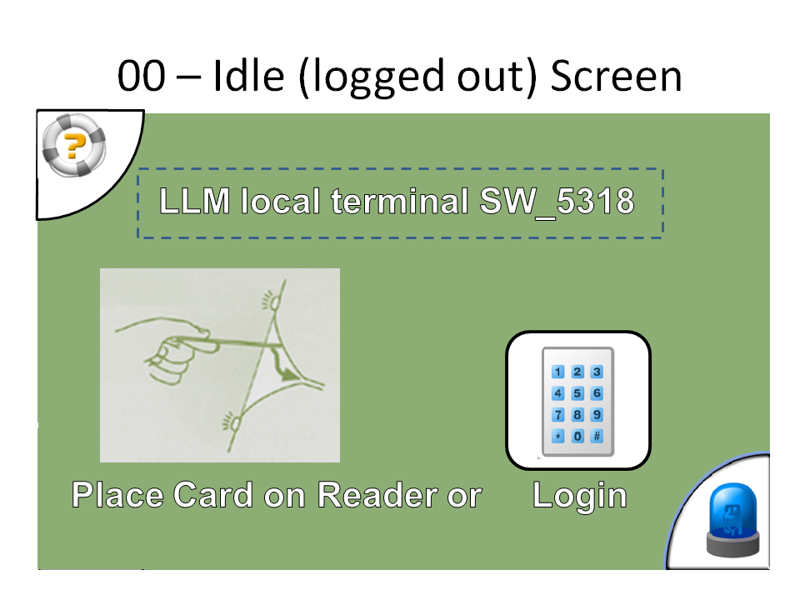 | - Title: System Configurable local terminal identification  - Picture + Text Label: "present login token / smart card (if configured!)  - Button: "manual login"  - Button: "Help"  - Button: "Distress"

LLMCMSS.06.04.01 - Manual Login screen
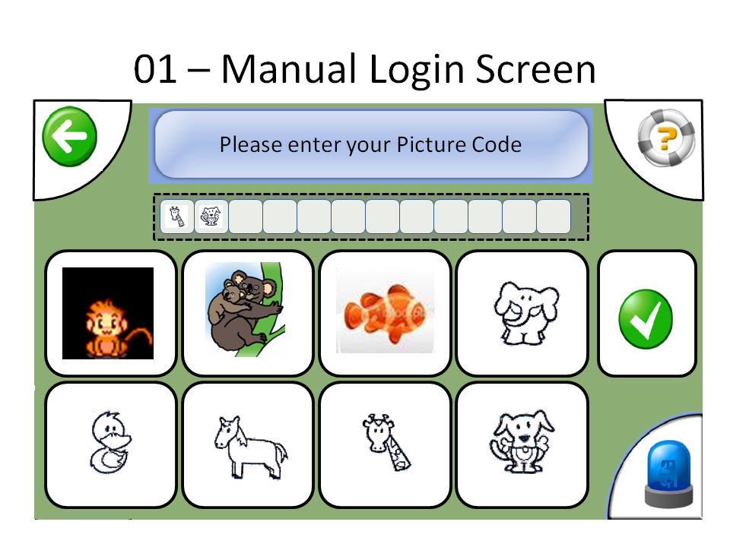 | - Title: (Enter Picture Code) System-Configurable title  - 8 Buttons for 8 available picture glyphs  - display area to show already entered picture code part  - Button: "Enter/Submit"  - Button: "Back"

LLMCMSS.06.04.02 - LLM senior main menu screen
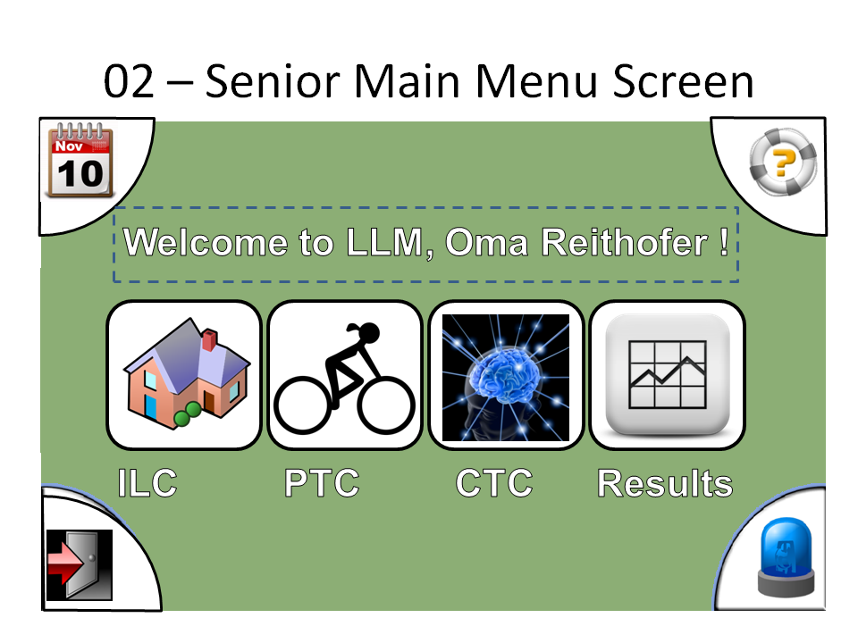 | - Title: User-Configurable main menu banner (text/logo/graphics)  - Button: "Manage Schedules"  - Button: "View Results"  - Button: "Physical Training" - if user has rights  - Button: "Cognitive Training" - if user has rights  - Button: "Switch to ILC" - if user has rights  - Button: "log out"  - Button: "Emergency/Distress"  - Button: "Help"

LLMCMSS.06.04.05 - training program reminder notification
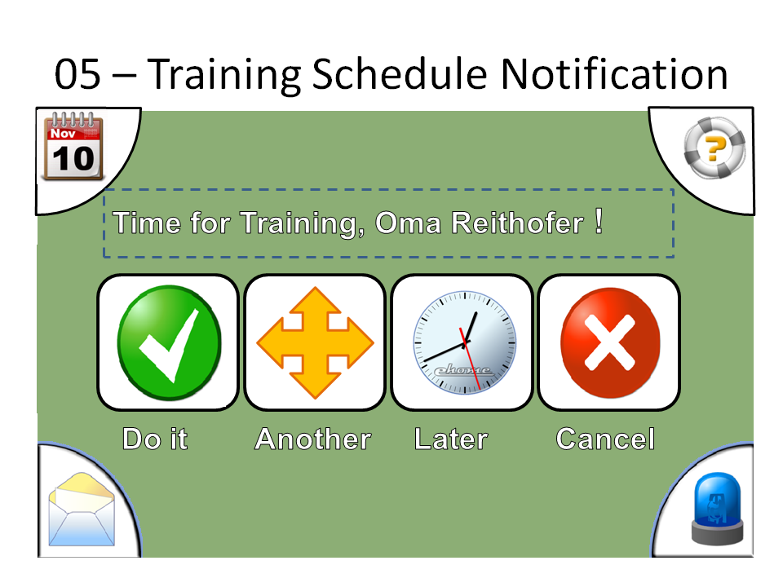 | - Title: "it's time for your training" or other configrable text/logo/graphics + scheduled time  - Text: name of senior  - Text: type of training (cognitive/physical)  - Text: name of training program  - Button: "start training"  - Button: "start another training" - if senior has another active traning program of this type  - Button: "remind me later"  - Button: "Cancel"

LLMCMSS.06.04.06 - physical / cognitive training selection screen
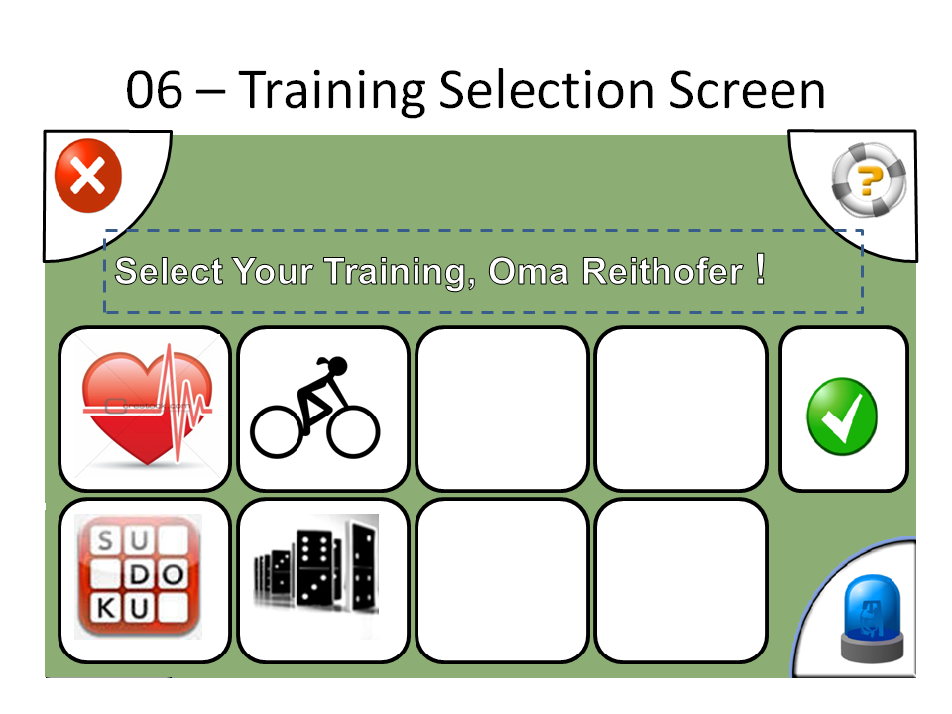 | - Title: "Select yout training program" or other configrable text/logo/graphics  - Text: name of senior  - Button set:  for each of the active training programs for the senior  one button with text or picture determined by the  training type (physical/cognitive) class(cardio/fat-burn/... or sudoku/memorize/...); maximum of 2 rows with 4 buttons each,  to not exceed window real estate, have reasonable size and produce no overload  - Button: "Cancel"

LLMCMSS.06.04.07 - training result screen
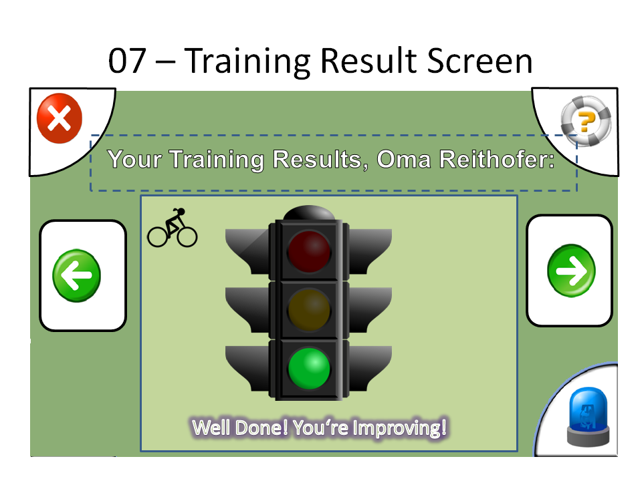 | - Title: "Training results ..."  - Text: name of senior  - display frame (HTML): feedback data from last event  - button "previous" - active if more results available matching the request  - button "next" - active if more results available matching the request  - Button: "OK"

LLMCMSS.06.04.08 - recovery response dialogue
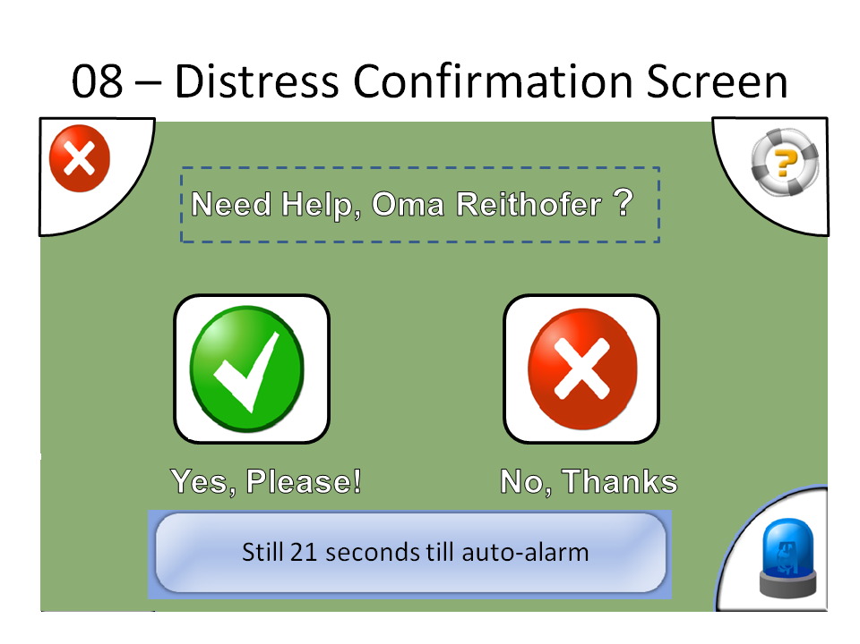 | - Title: "do you need help?"  - Text: name of senior, description of local terminal site (with associated PTC)  - Button: "I'm OK"  - countdown display: seconds until response timeout  - Button: "I'm unwell"  - Behaviour:  - opening dialogue starts response timeout  (configurable RECOVERRESPONSETIMEOUT), timeout generates timeout event to CMS  - Button "OK" or "unwell" stops timeout and dismisses dialogue  - countdown display updates every second and show seconds until timeout

LLMCMSS.06.04.09 - process active display screen
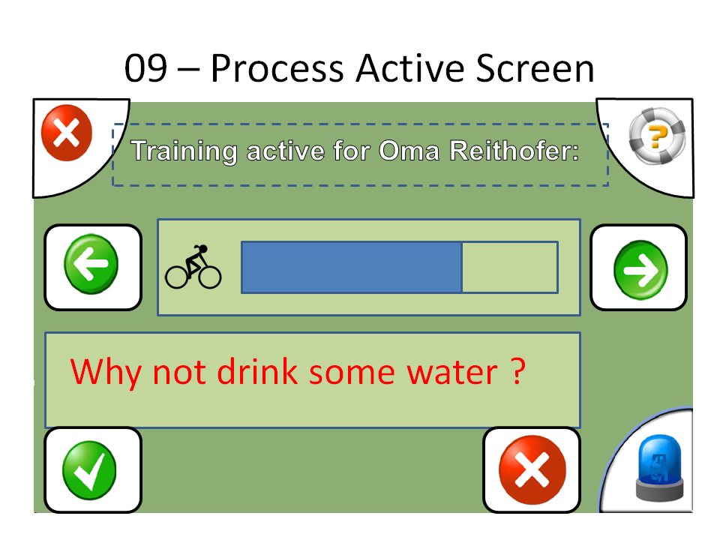 | - Title: "Training Active" (shall be configurable to be re-useable for other activity status displays)  - HTML status display area with 2 buttons:  "previous status message",  "next status message"  - HTML instruction display area with 2 buttons:  "OK / did it",  "not understood / could not do it / did not do it"

LLMCMSS.06.04.10 - help screen
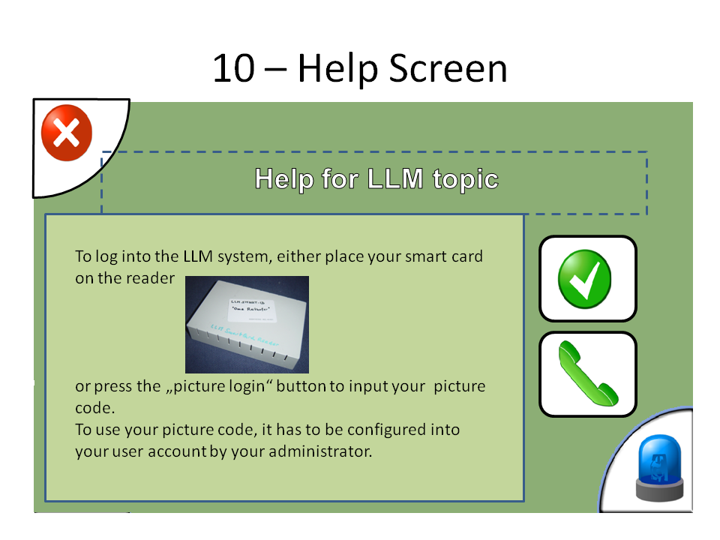 | - Title: "Help for ... " (Configurable per help topic)  - HTML help display area  - button: "OK"  - button: "voice/video call for more help"

LLMCMSS.06.04.11 - schedule list
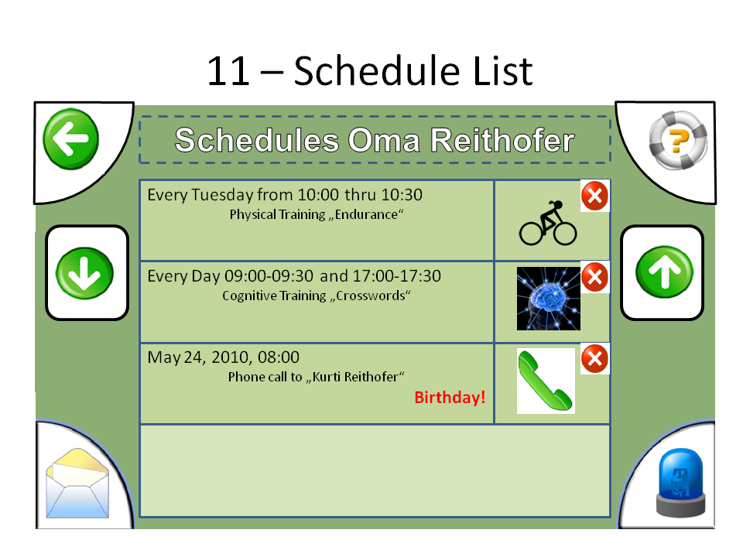 | - Title: Schedules for <username"  - list with 4 components to each scheduled event:  - time and repetition  - event type icon  - event details  - comment or remark  - if list longer than 4 entries:  - NEXT button to scroll down  - PREVIOUS button to scroll up

LLMCMSS.06.05 - administration and management use cases

LLMCMSS.06.05.01 - Logging in at RUI
Environment: RUI
Start State: 501.1
State 501.1: home URL of LLM RUI openend, welcome screen displayed
Event 501.1.1: user enters valid username and password
Action 501.1.1: RUI processes input, CMS verifies credentials, creates session, associates with web session, copies user rights into session, RUI creates main menu items, display main menu, -> State 502.1
Event 501.1.2: user enters invalid credentials in login form, submits form
Action 501.1.2: RUI processes input, CMS verifies credentials, rejects with error message, RUI displays error message, -> State 501.1

LLMCMSS.06.05.02 Configuration / Property object editing
This use case with associated dialogues shall be used for access to all manageable and configurable parts of the LLM-DB. Specific structures (senior/member/user/...) shall be mapped as part of a virtually connected "tree" that can be traversed and edited with this dialogue. The API to provide this virtual view is specifid in LLMCMSS.04.02.14.
If the respective controls are available in the employed web application component framework, the configuration editor shall as close as possible resemble the windows registry editor or the respective parts of the windows file explorer to allow for intuitive handling by the administrators.
Environment: RUI
Start State: 502.1
State 502.1: RUI main menu displayed
Event 502.1: user selects menu item "property object editor"
Action 502.1: initialize current context to "/", current page-offset to 0, enter state 502.2
State 502.2: list of properties displayed
On_Entry_Of_State 502.2: display "N" properties of the current context at the current page-offset, 1 row per property with 3 columns (name, type, value), plus 1 empty row for adding a new property, all fields editable text fields, each row with "submit change" and "delete" button, new-property row with "add" button
Event 502.2.1: user presses "Next" or "previous" button
Action 502.2.1: set page-offset to + or - "N", re-enter state 502.2
Event 502.2.2: user enters new values in a row and presses adjacent "submit change" button
Action 502.2.2: RUI writes back changed property, re-enter state 502.2
Event 502.2.3: user enters new values in empty "add" row and presses "add" button
Action 502.2.3: RUI adds new property, re-enters state 502.2
Event 502.2.4: user presses "delete" button next to a property entry
Action 502.2.4: display delete confirmation dialogue, -> state 502.4
Event 502.2.5: user presses "EXPORT" button of form
Action: 502.2.5:RUI generates XML file output document, browser pops up "save/open" dialogue, stay in state 502.2
Action: 502.2.6: user presses "IMPORT" button of form
Action 502.2.6: RUI pops up Import dialogue LLMCMSS.06.06.06.02, execute import, refresh actual displayed page, but revert to page 1, back to state 502.2
Event 502.7: user enters new path and presses "GO TO" button of context path area
Action 502.7: accept new path, re-enter state 502.2
Event 502.8: user presses "one level upward" button of context path area
Action 502.7: go back one level upwards in path, re-enter state 502.2
State 502.4: delete confirmation dialogue displayed
Event 502.4.1: user presses "OK"
Action 502.4.1: RUI calls "Delete_Property()" with CMS, CMS with LLM-DB, refresh list view, -> state 502.2
Event 502.4.2: user presses "Cancel"
Action 502.4.2: return to property list view, -> State 502.2

LLMCMSS.06.06 - RUI screens

LLMCMSS.06.06.00 - General LLM RUI screen layout
- There shall be a constant layout of all RUI screens and dialogues according to picture 06.06.00.
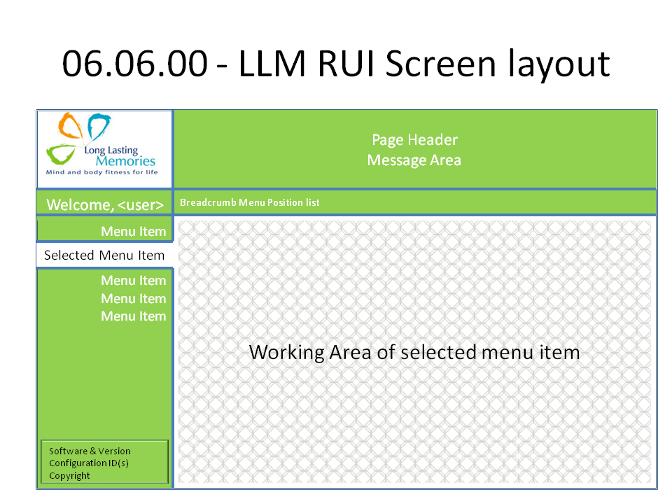 | - All Attributes of the following screen definitions apply to the working area, except for:  - Title - shown in "Page header"  - navig-pos: shown in "breadcrumb menu position list"  - Message - shown in "Message Area"
- Whenever a menu is entered, there shall be a default entry selected
- Whenever a menu item is selected (also if it is selected by default when the menu is entered) its working area shall already be displayed.
- Depending on the nature of a menu item, the default displayed work area at selection of the menu item shall already show an initial data set, e.g. the last training result of the currently selected senior.

LLMCMSS.06.06.01 - Idle/Welcome/Login screen
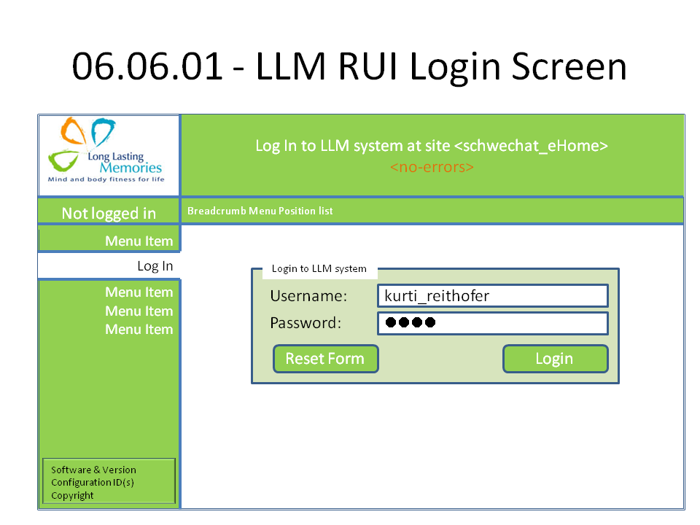 | - Title: Configurable: Welcome to LLM instance ...  - Form: login to LLM RUI  - Username: text entry with label  - Password: text entry with label, no input echo (password field)  - Reset Button "Reset Form"  - Submit Button: "Login to LLM"  - Message: status message, initially empty  - Disclaimer(s) and Privacy Caveats: configurable HTML paragraph  - Advertisments and Sponsor messages: configurable HTML paragraph

LLMCMSS.06.06.06 - configuration object / property list display
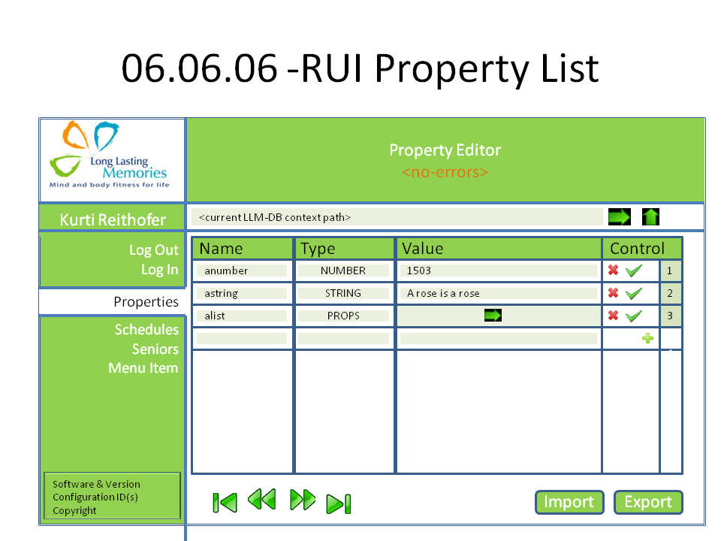 | - Title: "Object List <path-or-identifier>" editable  - Button "go to" - to accept changed path and go to there  - "Page <n> of <k>", "n" bein editable  - Button "Go to page" - to change to entered page  - Button "Up" to go up in hierarchy, if applicable  - Table with headers:  - ordinal number in current result set  - for object list:  - unique ID of object  - value of 1st object attribute  - value of 2nd object attribute  - for single object:  - name of object attribute  - type of object attribute  - value of object attribute  - for property list:  - name of property  - type of property  - value of property  - if applicable: DELETE button  - if applicable: SUBMIT CHANGES button  - button: "FIRST page"  - button: "NEXT page"  - button: "PREVIOUS page"  - button: "LAST page"  - button: "IMPORT"  - button: "EXPORT"

LLMCMSS.06.06.06.02 - Import property pop-up dialogue
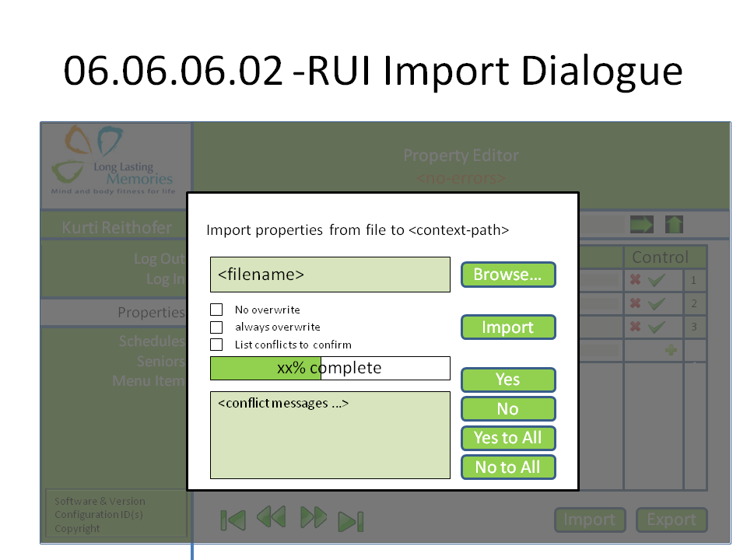 | - title including path where properties are to be imported  - file name selection for import file including BROWSE button  - radio button set for handling of already existing property names:  - overwrite always  - overwrite never  generate list of import conflicts  - button: "IMPORT"  - progress bar  - message field for issues to be confirmed  - response for conflict issues:  - button YES  - button YES to ALL  - button NO  - button NO to ALL

